Movie Selector Tutorial Transcription

# GROUP BOXES

A group box must be inserted before you can insert a group of controls which belong together. This is usually true with radio buttons, but may also be used with other controls. In short, group boxes are used mostly for visual organization of controls. The prefix for a group box is grp.

1. **Open a new project**
2. **Select the form and click on the properties box.**
3. **Change the Form name to "Movie Selector".**
4. **Insert a label (using the toolbox).**
5. **Name the label lblTitle; change the font size to 20; and change the text to Movie Selector.**
6. **Choose the group icon from the toolbox and draw a long rectangle on the form.**

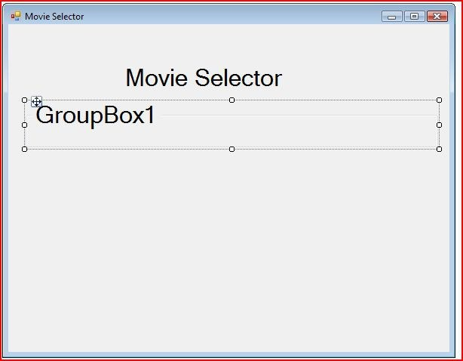

# RADIO BUTTONS

**Radio buttons** are inserted in groups (grouped by a groupbox) and only one can be selected at a time. Radio buttons allow the user to make choices.Radio buttons will not function as expected if they are not grouped in a group box. To move a radio button into a group box, select the RadioButton object, select Edit / Cut, select the GroupBox object, and then select Edit / Paste. The naming prefix for each radio button is rad.

In addition to most of the other properties that have been discussed previously, radio buttons also have a **checked property.** The checked property can either be set to true or false. True means that it is selected and false means that it is not selected.

In order for the form to work, the radio buttons must be programmed. In addition to the GUI, you also have a set of instructions that tells the computer what to do. This is code. A way to view all of the code from start to finish

is to click on the  in the Solution Explorer box. A block of code that has very specific instructions is a **procedure. An event procedure (**also called an **event handler)** responds based on user interactions. You can select the object in the Class Name list box of the code window.

When a user clicks on a particular control object, the program may be written to react. For example clicking on a radio button in our Movie Selector program, will cause a movie recommendation to appear. This is called a **Click event**. The easiest way to write a click event is to double click on the same object you expect the user to click on. This will bring you to the code window in the exact spot you should write the code.

The image below shows the code for radMovieType1. Please note that when a radio button is doubleclicked a

line which begins with"Private Sub" will be there as well as a line that begins with "End Sub". The line(s) between these are typed by the programmer. In this case the code commands that the text of lblMovieTitle be changed to read "Cheaper By The Dozen".



Me refers to the form that you are currently working in. lblMovieTitle is the label that was created to display the results and .Text is the attribute of lblMovieTitle that you are about change or set equal to "Cheaper By the Dozen". Notice the quotation marks. They tell the VB compiler that text is to be printed rather than a value (or number).

In this tutorial you will create radio buttons that will represent different genres of movies. You may choose your own genres if you prefer. We are going to program the radio buttons so that when a particular radio button has been clicked the name of an appropriate movie appears in the label. **You need to have 6 movie genres and the movies that match to their genre you should have 6 radio buttons.**

1. Place 6 radio buttons from the tool box within the groupbox you created in the last tutorial.
2. Name each radio button radMovieType1, radMovieType2, radMovieType3, adMovieType4, adMovieType5, and adMovieType6 respectively. Naming the buttons descriptive yet generic names allows us to change the genre's later without changing the name of the variable.
3. Set the Text property for each radio button equal to a different genre of movie.
4. Select a label from the toolbox and place it on the form.
5. In this label, we will print the name of a movie recommendation for a particular genre. On the form shown below, this label is named lblMovieTitle.
6. Double click on radMovieType1. In the appropriate spot (between "Private Sub".... and "End Sub")The image below shows the code for radMovieType1.



1. Each radio button should be individually clicked on and similar code should be typed.

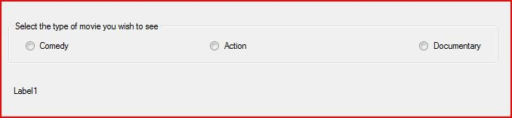

# Give this a shot

# BUTTONS

Another control which can be used to allow users to make choices is a button. The prefix for a button name is btn. Buttons are programmed in a similar way to radio buttons. The programmer should double click on the button and write the code in the appropriate spot.

This tutorial will add to the Movie Selector project you began in Tutorial 3-6. This part will use buttons to calculate how much you are spending on your movie rental. Buttons will be added to the program to allow the user to choose whether they will be renting one, two, or three movies.

1. **Create a new label. The one in the picture below is named lblQuantity. In the properties box, change the text to "How many movies will you be renting?".**
2. **Use the button tool in the tool box to create 3 buttons on the form under lblQuantity. The buttons in the image below are named: btnQuantity1, btnQuantity2, and btnQuantity3. The text for the buttons should be numbered from 1 to 3.**

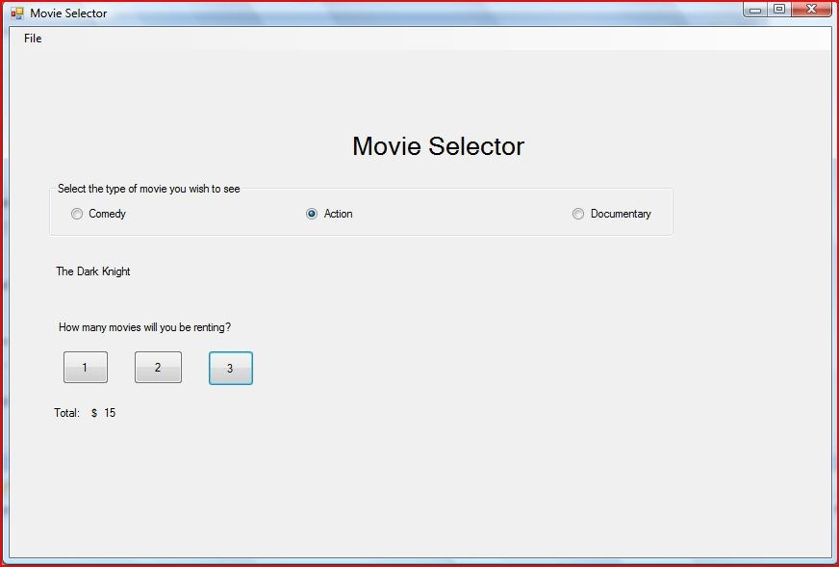

# CALCULATIONS

Many applications use calculations for various reasons. The calcuations in VB are done in similar ways to other place where calcuations are used such as math class and spreadsheets.

VB recognizes many of the same symbols that are used in spreadsheets and many graphing calculators.

+ Addition

- Subtraction

/ Division

* Multiplication

Also similar to math class and spreadsheets, VB uses the order of operations. This is the order in which calculations will be made within the same statement. For review the following is the order.

•Parenthesis

•Exponents

• Multiplication & Division

•Addition and Subtraction.

The buttons that were created in the last section can not do calculations alone. The buttons must be programmed to complete the caculations.

1. Create a label to display our calculations named lblTotal and has the text: "Total: $".This will allow us to automatically have the number represent a currency
2. Create another label to describe the label that is displaying our calculations named lblTotalCost. Your form should look similar to the picture below.

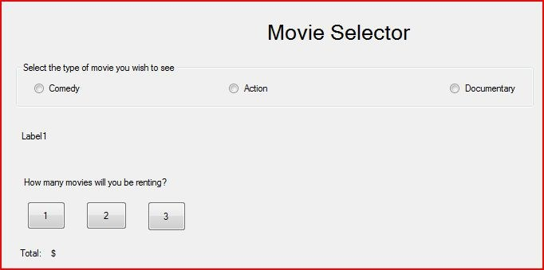

1. Double click on btnQuantity1. In the appropriate area insert the following

code:  The above code calculates the value of 1 multiplied by 5 and prints the code in lblTotalCost using the Text attribute.

1. Double click on btnQuantity2 and insert the following code in the appropriate area:

 The above code is similar to the code for btnQuantity1 except that 5 is

now multiplied by 2. btnQuantity3 will work the same way except that we will multiply 5 times 3.

# MENU STRIPS

A menu strip is list of options or commands across the top of the window written in words. This is an example of a menu strip taken from Microsoft Word 2003:



If you were to click on each of the words in the example above, you would get more options such as open, save, print, exit, and more. Putting the ampersand infront of a particular letter allows a user to use Alt + that letter to access the File menu

The next step in creating the Movie Selector program is to insert a menu strip. Our menu strip will only include to option to close the program for now.

1. Click on the  tool box icon and insert a menustrip object.
2. Once you have placed the menustrip on the form, you will see boxes which have a place to type text In the first box, type &File. Putting the ampersand infront of a particular letter allows a user to use Alt + that letter to access the File menu. A line usually appears under the F. A user with be able to hold down the Alt key and the f key at the same time to open the file menu. In the box under File you should type the word E&xit which will show up as Exit and allow the user to use Alt + x to close the application. Notice that you you can fill in other boxes to add more options.
3. Now the Exit option in the menustrip needs to be programmed. Double click on exit in the file menu and place the following code in the in appropriate place.



1. Now, when the program is run, clicking on Exit in the file menu will shut the program down.